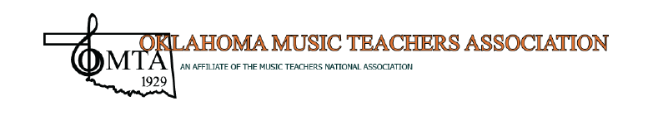

EXHIBITOR’S CONTRACT

The firm listed below requests exhibit space for the OMTA Conference to be held June 3-4, 2022 at the DoubleTree by Hilton Hotel-Warren Place, Tulsa, Oklahoma. Exhibits are scheduled for the Salon E Ballroom Foyer. Table locations will be assigned in the order of the contract received. OMTA is not responsible for loss or damage to exhibits.

Exhibit hours are: June 3 (Friday), 8:00-5:00 p.m./June 4 (Saturday) 8:00-4:30 p.m.
Exhibit set up time is: June 2 (Thursday), 1:00-5:00 p.m.
Exhibit take down time is: June 4 (Saturday), 4:30-7:00 p.m.

- Each exhibitor must provide an easel and printed sign for displaying the name of the exhibiting firm if they so wish.
- Exhibits must be on the tables provided and/or free-standing display.
- Nothing may be attached to the walls.
- No food or beverage may be on sale or distributed from exhibits.
- OMTA is not responsible for loss or damage to exhibits.
- Contracts CLICK HERE and payment in full must be submitted online (below) no later than 11:59 pm on April 29, 2022.
- The use of Wi-Fi and electrical outlets are available upon request.

The fee is $100 for each skirted table.

For questions regarding the exhibits, please contact Sandra Pierce – Exhibit Chair: spierce6770@gmail.com

Sandra Pierce
2716 West 67 Street
Tulsa, Oklahoma 74132
918-445-1639

