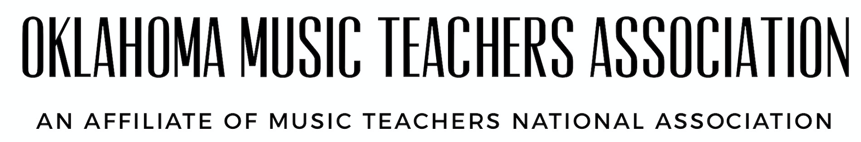
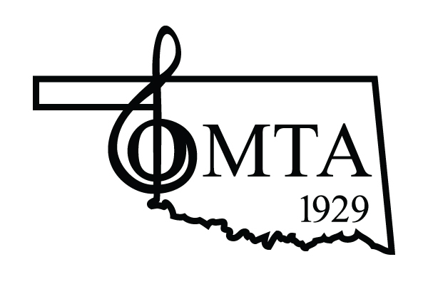

STATE ACHIEVEMENT AUDITIONS COORDINATOR
Revised June 2022

The Coordinator is a member of the OMTA Auditions and Competitions Committee and is also a member of the OMTA Board.

Responsibilities include:
- Secure the location of the audition.
- Secure adjudicators for the audition.
- Secure helpers and monitors for the audition. This would include teachers and college students.
- Schedule audition times. Send the schedule to the VP of Communications for posting on the OMTA website.
- Order an ample supply of awards. Unused awards are kept in the storage unit.
- Prepare adjudicators’ packets. Include: room schedule, OMTA rating system, adjudicator guidelines, and blank critique sheets. Also needed is a signed adjudicator contract and W-9 to be submitted to the OMTA Treasurer electronically.
- Be sure each audition room is labeled and printed directions are available.
- Be available during the audition to answer questions and to assist in any difficult situation.
- Other duties include: set up, tear down, food orders, etc…

*Check Policies and Procedures for more information.

Expenses incurred by this office may be reimbursed by electronically submitting (via OMTA website) the OMTA Officer Expenses Form.

It is the responsibility of each Officer and Chair/Coordinator to maintain an updated list of duties specific for each position. Each time a change is made, email the revised page to the President for distribution to the VP for Communications. Please keep a flash drive with pertinent files to pass on to the next Officer at the end of the term.

APPLICABLE TO ALL OMTA COMPETITIONS AND AUDITIONS
The professional image of OMTA: The audition Chair is a professional administrator before, during, and after the event. The work of all OMTA members promotes the public image of the Association. The format of the Competition or Audition schedule, the neatness of signs, the sincerity in welcoming students, parents, and teachers, and the kindness and tactfulness in dealing with problems directly affect the image of OMTA. The responsibilities of a Competition or Audition chair are many and time-consuming, but afford a feeling of satisfaction for a job well done. Without your efforts, OMTA could not provide for our students. At any time, even during the actual Competition or Audition, contact the Vice President of Competitions and Auditions for assistance in any matter relating to that particular event.

INITIAL RESPONSIBILITIES BEFORE THE COMPETITION OR AUDITION
1. Set the competition date, location and entry deadline.
2. Select adjudicator(s) for the event.
3. Secure monitors, helpers, timers or any workers needed.
4. Prepare extra critique sheets, report forms and instructions to monitors and workers. Prepare any signs or notices that will be needed on that day. The building and rooms used for the event must be clearly indicated for parents and students. A monitor or spokesperson should be on site at all times even during the lunch break.
5. Prior to the Competition, make sure the judges have received copies of the following:
- Audition schedule
- Blank Critique Sheets
- OMTA Guideline for Adjudicators
- OMTA Rating System

TEACHER ELIGIBILITY
1. Dues for the current year must have been paid by June 30. If the dues are paid after June 30, there will a $50 late fee incurred.
2. Reminder: a minimum of six months is required for the length of study, whether the student is new or a transfer student.

AFTER THE AUDITION
Expenses incurred by this office may be reimbursed by electronically submitting (via OMTA website) the OMTA Officer Expenses Form.

MONITOR INSTRUCTIONS
Meet with the Competition or Audition chair and adjudicators at the orientation session. Be pleasant and helpful to all students, parents, and guests. ILLEGAL reproductions of printed music (either by hand or machine) including transpositions and transcriptions may not be used by performers or accompanists or provided for adjudicators. The only exception to this rule is for music that is out of print or still in manuscript (not published). In either of these cases, the student must present written permission from the composer, publisher or the copyright holder. A teacher and Parent may be asked to sign a music release form. This rule is not based on the copyright law but is one made by MTNA in the interest of professional ethics. Reproduction of a single page but not the entire score may be used to facilitate page turns and the appropriate published score must also be present on the music stand and/or rack. Any violation of the above rule must be taken immediately to the chair before allowing the student to perform. Video or audio recording and photography at Competitions or Auditions are strongly discouraged and is a distraction to the performance and performer. This is the MTNA current position on this policy. Permit entrance in the audition room only between entrants. All OMTA Competitions and Auditions are open if the room size accommodates. Time the performance of each entrant at the Junior and Senior Competitions. Return music to the entrant. Music will not be mailed to the student or teacher at a later date. Discourage students, teachers, and parents from conversing with adjudicators before or during the time allotted for the competition or audition. Monitors: Measures do not need to be individually numbered, only the beginning of each line or system (Grand Staff ).
OMTA GUIDELINES FOR ADJUDICATORS
The aims and objectives of OMTA Competition and Auditions are to stimulate and encourage students.

PLEASE DO:
- Make the student feel welcome.
- Permit the student a brief second warm-up.
- The student determines what to play during the warm-up but may be stopped by the monitor or adjudicator if it is too long.
- Give clear, concise, constructive criticism dealing with specific elements of the performance.
- Give some encouragement regardless of how inadequate the performance.
- Make sure the comments substantiate the rating.

PLEASE DO NOT:
- Make comments that might discourage the student or reflect unfavorably on the teacher.
- Attempt to teach the student your own technical or musical theories.
- Ask the student to make changes in his/her performance by omitting repeats or other changes in the interest of time. The student should play the entire piece only one time.
- Mark in the entrant's music.
- Make comments concerning the suitability or repertoire.
- If there is a question concerning the entry, confer with the chair immediately.

REMEMBER:
All OMTA Competitions and Auditions are open to the public. Anyone desiring to observe may do so if the room is large enough. Video or Audio recording and photography at competitions and Auditions are strongly discouraged by MTNA/OMTA.

